DATA LOADING FUNDAMENTALS

1. Snowflake Stages (Core Concept)
A stage is a location where data files are stored before loading into Snowflake tables.
Types of Stages
1. Internal Stage
- Managed by Snowflake
- Used for:
  - Quick uploads
  - Testing
- No external cloud dependency

2. External Stage
- Stored in:
  - AWS S3
  - Azure Blob
  - GCS
- Requires:
  - Credentials
  - Integration setup

Key Difference
Feature | Internal | External
Storage | Snowflake | Cloud
Setup | Simple | Requires config
Use Case | Small/temporary | Production pipelines

2. File Formats

Supported Formats
Format | Type | Use Case
CSV | Structured | Tabular data
JSON | Semi-structured | APIs/logs
Parquet | Columnar | Big data

File Format Object
- Defines how Snowflake reads files:
  - Delimiter
  - Header
  - Compression

3. COPY INTO Command (MOST IMPORTANT)

Purpose
- Load data from stage → table

Flow
Stage → COPY INTO → Table

Example
COPY INTO customers
FROM @stage_name
FILE_FORMAT = (TYPE = 'CSV');

4. Bulk Loading

Key Characteristics
- Parallel execution
- High performance
- Handles large datasets

Best Practices
- Use:
  - Large files (100MB–1GB)
  - Compressed formats (gzip)

5. Loading Structured Data

Example
- CSV → Table
Key Points
- Fixed schema
- Direct column mapping

6. Loading Semi-Structured Data

JSON Handling
- Use VARIANT data type

Example
SELECT data:name FROM json_table;

7. Loading Unstructured Data

Supported via:
- External stages
- Snowflake native support (Snowpark, external functions)

Examples
- Images
- PDFs

8. SnowSQL CLI

What is it?
- Command-line tool for Snowflake

Use Cases
- Automation
- Script execution
- CI/CD pipelines

MODULE 5 — CONTINUOUS & ADVANCED LOADING

1. Snowpipe (Continuous Ingestion)

What is Snowpipe?
- Serverless ingestion service in Snowflake
- Automatically loads data when files arrive

Flow
Cloud Storage → Event → Snowpipe → Table

Benefits
- Real-time ingestion
- No manual COPY required
- Scalable

2. COPY Options (Important for Interviews)

PURGE
- Deletes file after load

ON_ERROR
Option | Behavior
ABORT | Stop
CONTINUE | Skip bad rows

FORCE
- Reloads already loaded files

MATCH_BY_COLUMN_NAME
- Maps columns dynamically

3. Unloading Data

Purpose
- Export data from Snowflake

Example
COPY INTO @stage
FROM table_name
FILE_FORMAT = (TYPE = 'CSV');

4. Data Loading Best Practices

Performance
- Use:
  - Large files
  - Parallel loading

Reliability
- Handle errors properly
- Validate data

Cost Optimization
- Avoid reloading same files
- Use Snowpipe for streaming

MODULE 6 — DATA PROCESSING & SQL

1. Scalar Functions

Definition
- Operate on single value

Examples
UPPER(name)
LENGTH(name)

2. Aggregate Functions

Definition
- Operate on multiple rows

Examples
COUNT(*)
SUM(amount)
AVG(value)

3. Window Functions (VERY IMPORTANT)

Purpose
- Perform calculations across rows without grouping

Examples
ROW_NUMBER()
RANK()
LEAD()
LAG()

Example Use Case
- Ranking customers
- Running totals

4. Stored Procedures

Purpose
- Encapsulate business logic

Language
- JavaScript (native)

Use Cases
- Complex workflows
- Reusable logic

5. Streams (Change Data Capture)

What is a Stream?
- Tracks changes:
  - INSERT
  - UPDATE
  - DELETE

Use Case
- Incremental processing

Flow
Table → Stream → Task → Target Table

6. Tasks (Scheduling)

Purpose
- Automate SQL execution

Features
- Cron scheduling
- Dependency chaining

Example Use Case
- Run ETL every hour

7. Materialized Views

What are they?
- Precomputed query results

Benefits
- Faster queries
- Automatic refresh

Trade-offs
- Storage cost
- Maintenance overhead

END-TO-END ARCHITECTURE

Typical Pipeline

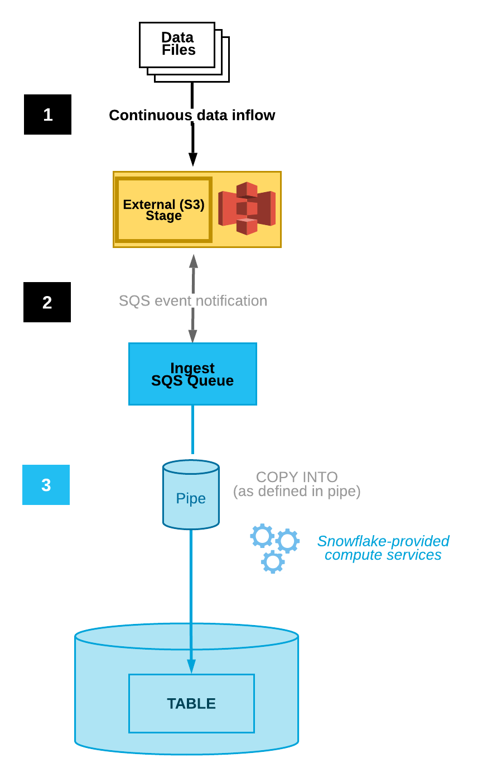

HOW TO STUDY EFFECTIVELY

Day-wise Plan
Day 1
- Stages + COPY INTO
Day 2
- Snowpipe + advanced loading
Day 3
- SQL + Streams + Tasks

COMMON MISTAKES

- Using small files → poor performance
- Not using compression
- Reloading same data repeatedly
- Not monitoring Snowpipe

